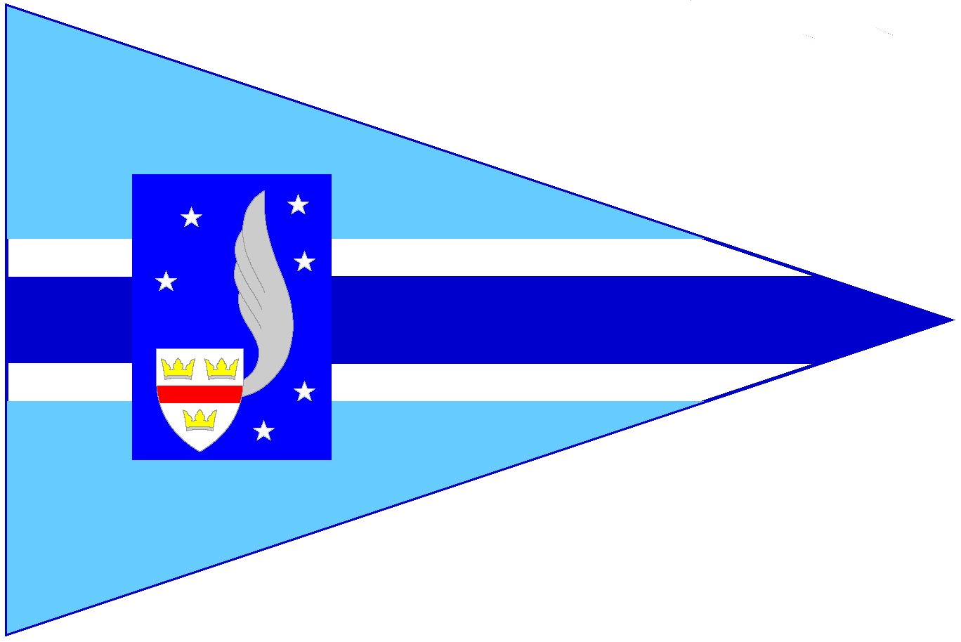**Silver Wing Sailing Club**

Membership ApplicationForm - 2025/2026

1) All Membership applicants

|  |  |  |  |  |  |  |  |  |  |  |
| --- | --- | --- | --- | --- | --- | --- | --- | --- | --- | --- |
| Family name | | | | First name | | | | Known as | | |
| Date of Birth *if under 18 years** or 24 if in full time* *education* | | | | | |  | | *\*\* See Parent/Guardian declaration* | | |
| Home address | |  | | | Preferred contact address if different from home address. | | | | | |
|  | | | | |
|  | | | | |
|  | | | | |
|  | | | Post code | |  | | | | Post code | |
| Phone number | Home | | | |  | Please mark the box(es) of the numbers you prefer to be contacted on, If required in emergency | | | |  |
| Work | | | |  |
| Mobile | | | |  |
| Email  address | Home 1. | | | | | |  | Give only addresses you check regularly. If you do**NOT** want an address published please type ‘X’ in the relevant box(es) | | |
| Home 2. | | | | | |  |
| Work | | | | | |  |

2) Family membership applicants

|  |  |  |
| --- | --- | --- |
| Name of spouse/partner | | *Family membership of the Sailing Club is required where family members wish:*   * *To sail or paddleboard,* * *To visit the Club independently ** or,* * *To visit the Club on a regular basis.*   *\*\* See Parent/Guardian declaration for children under the age of 18 years at date of joining.* |
| Names of children (Aged 5 and over only) | Age |
|  |  |
|  |  |
|  |  |
|  |  |

|  |  |  |  |
| --- | --- | --- | --- |
| 3) Experience and Qualifications | |  |  |
| Dinghy sailing | Other: e.g. Safety boat/First aid |
| Family (Names) | Self |  |  |
|  | |  |  |

4) Boats owned and to be sailed at the club / Request for berth(s)

|  |  |  |  |  |  |
| --- | --- | --- | --- | --- | --- |
| Class of Boat | | Hull/sail # | Hull colour | Berth | Please **✓** or enter ‘Yes’ in the ‘Berth’ box(es) if required  *Berths are allocated by the Harbour-master (See Membership Guide)*  *All boats* ***must*** *be insured to a min. amount of £3M against 3rd. party risks* |
| 1. |  |  |  |  |
| 2. |  |  |  |  |
| 3. |  |  |  |  |

5) Disability Discrimination Act 2005

|  |  |
| --- | --- |
| *If you, a member of your family or guest that you may expect to bring to the Club has any disability or impairment that may require special treatment or facilities please enter brief details here.* |  |

6) Data Protection

|  |  |  |
| --- | --- | --- |
| The information you provide on this form will be used solely for dealing with you as a member of Silver Wing Sailing Club.  Your data will be stored and used in accordance with. the Club Data Privacy Policy which can be viewed on the Club website. . | | |
| The Club may arrange for photographs or videos to be taken of Club activities and published on the Club or social media channels to promote the Club | If you consent to your image being used by the Club in this way, please tick here **>>** |  |
| If at any time you wish to withdraw your consent for any of the above, please email membership@silverwingsc.co.uk | | |

7) Classes of Sailing Club membership

|  |  |  |
| --- | --- | --- |
|  | Applicable to: | Privileges |
| Sailing  (Single Adult) | Adults aged 18 years or over at date of joining. | * Unlimited access to sailing and to all the facilities at Wraysbury subject to Sailing Club rules and byelaws. * May introduce and sail with a guest on an occasional basis. * Full voting rights. |
| Sailing (Family) | The spouse or partner and all children under the age of 18 (24 if in full time education) of an Adult Sailing member. | * As Single Adult (See Club Rules for Voting Rights).   *(For independent access and sailing rights Family members must be>15 years of age. Members under 18 require Parent/Guardian consent and Club approval*. |
| Sailing (Student) | Young Person age of 18 to 24 and in full time education | * Unlimited access to sailing and all the facilities at Wraysbury subject to Club rules and byelaws |
| Sailing (Junior) | Children under the age of 18 and in the care of a Sailing Member (Adult or Family) or Social/Shore Based Member | * Access to sailing and facilities at Wraysbury subject to Club rules and byelaws.   *(See ‘Family’ for access rights).* |
| Social | Adults aged 18 years or over at date of joining. | * Access to clubhouse and shore facilities at Wraysbury subject to Club rules and byelaws. * May sail with a Sailing Member on an occasional basis. |

8) Additional facilities

|  |  |
| --- | --- |
| Dinghies / SUPs | *The Club fleet of dinghies and SUPs are available for use at Wraysbury by Full, Family and Junior members. Use is subject to payment of Club facility fees as indicated below.* |

|  |  |  |  |  |  |  |  |  |  |  |  |  |
| --- | --- | --- | --- | --- | --- | --- | --- | --- | --- | --- | --- | --- |
| 19) Fees | |  | | | | |  | | | | | |
| Enter the appropriate individual fees and total them in this column ▼ | | | | | | *These fees will be paid by Direct Debit via our agent GoCardless.*  *Membership runs annually for one year minimum and by signing this form you are committing to this.* | | | | |
| Enter your requirements ( **✓** or number) as appropriate in this column ▼ | | | | | | | £ |
| Select **Annual / Monthly** fees (delete as applicable) | | | | | p.a. / p.c.m. |  |  |
| Club membership Annual/Monthly fees | | | Single Adult | | £130 / 11.00 |  |  |
| Single Adult (Under 24 or Over 65) | | £100 / 8.50 |  |  |
| Family | | £160 / 13.50 |  |  |
| Student/Junior/Social | | £50 / 4.50 |  |  |
| Annual/  Monthly Facility Fees | Dinghy berth(s) each. (State number) required) | | | | £40 / 3.50 |  |  | Membership Duties  Type of Duty Preferred  (Please Tick or Type ‘X’) | | | | |
| Use of Club SUPs | | Single Adult, Student, Junior | | £12 / 1.00 |  |  |
| Family | | £24 / 2.00 |  |  |
| Use of Club Dinghies and SUPs | | Single Adult, Student, Junior | | £60 / 5.00 |  |  |
| Family | | £90 / 7.50 |  |  |
| If paying for one or more Dinghy berths | Single Adult | £50 / 4.50 |  |  | Self  Family | | | | |
| Family | £60 / 5.00 |  |  | Sailing |  |  |  |  |
|  | **Total** | |  | House |  |  |  |  |
|  | | | | |

10) General Declarations

*Please read the Declarations carefully before signing.* 

*If you do not understand the significance of any item please ask a Club committee member for advice*.

When you have completed this Membership Application Form and signed the relevant Declaration(s) please sent it to the Membership Secretary by email as a pdf file bearing the family name, to:

membership@silverwingsc.co.uk

* *We will observe all rules and bylaws with regard to the use of the Club premises, facilities and sailing water at Wraysbury and will comply with any reasonable request or instruction made by a Club officer.*
* *I have read the Club safety advice online and understand that I and any person using the Club under my patronage or participating in any activity organised by the Club and its officers, wherever held, my family and any guest which I introduce to the Club do so entirely at their own risk.*
* *All boats owned by me and used on the water at Wraysbury are in a seaworthy condition and fully insured against 3rd. party risks to a minimum of £3M.*
* ***I understand that all Adult Sailing members and Family members aged 18 and over are required to serve on the Duty rosters covering the days of Club operation and to assist with maintenance tasks performed by members*.**

Signature …………….…………………. Date ………………….

11) Parent/Guardian Declaration (If applicable)

I am the Parent/Guardian of the Junior member(s) named in this form and accept that I am responsible for their safety while they on SWSC premises or taking part in Club activities. I do not hold the Club in loco parentis.

Signature ………….…………………..… Date ………….……..

For further information on Club history, facilities programmes, joining, etc. please visit our website:

[http://www.silverwingsc.co](http://www.basailing.org).uk